Entregable 1 – Agustin Sau.

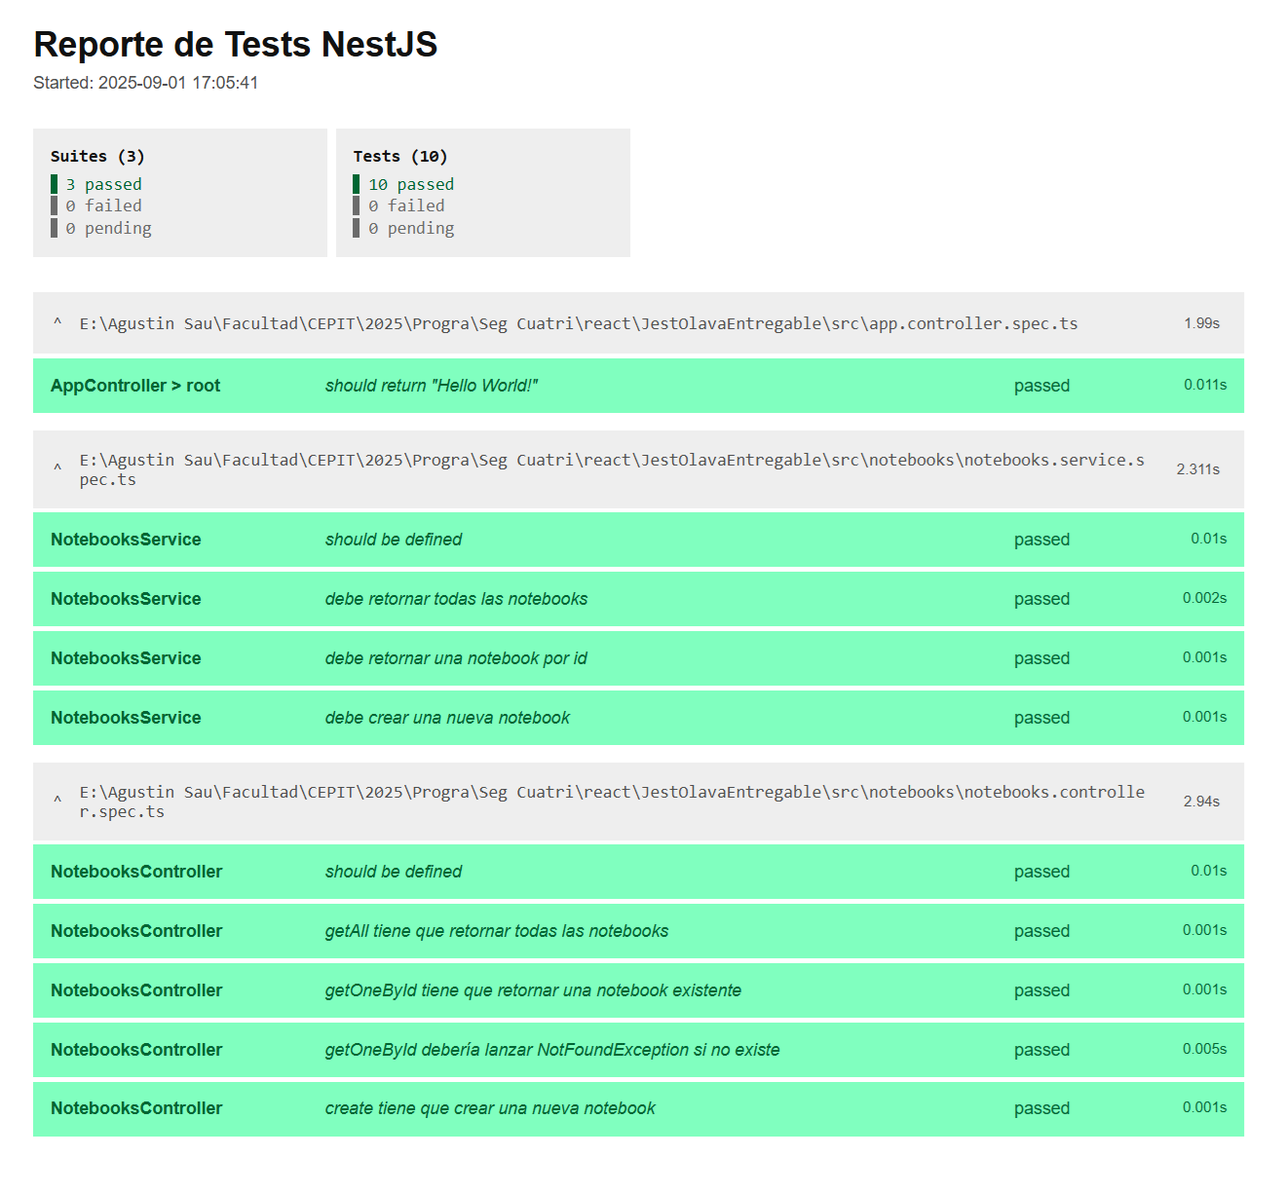

Repositorio Git:

https://github.com/agustinsau/entregables-prog-CEPIT-2025